Developing a Database

# Functional requirements

Functional Requirements:

Data Storage and Management:

* Customer Information:
  + Name
  + Contact details (address, phone, email)
  + Vehicle details (make, model, year, VIN)
  + Service history
  + Payment information (invoices, payment methods, outstanding balances)
* Repair Orders:
  + Date of service
  + Description of repairs
  + Parts used
  + Labor hours
  + Costs
  + Status (open, in progress, completed)
* Inventory:
  + Parts in stock
  + Prices
  + Vendor information
* Employee Information:
  + Name
  + Contact details
  + Job title
  + Skills and certifications
  + Schedule

# User requirements

User Interface:

* Intuitive and user-friendly interface, accessible through web-based or desktop application.
* Clear navigation and search options.
* Information displayed in a clear and organized format.
* Easy data entry and editing.

Data Entry and Maintenance:

* Add, edit, and delete customer, repair, inventory, employee, and financial records.
* Validate data to prevent errors and inconsistencies.
* Provide clear error messages and guidance for troubleshooting.

Data Analysis and Reporting:

* Generate customizable reports on repairs, inventory, employee productivity, and financial performance.
* Offer filtering and sorting options.
* Provide data visualization tools for better understanding of trends and patterns.

Search and Retrieval:

* Search for data using various criteria, including full-text search capabilities.
* Display search results in a clear and concise format, highlighting key information.
* Allow users to refine searches based on specific criteria.

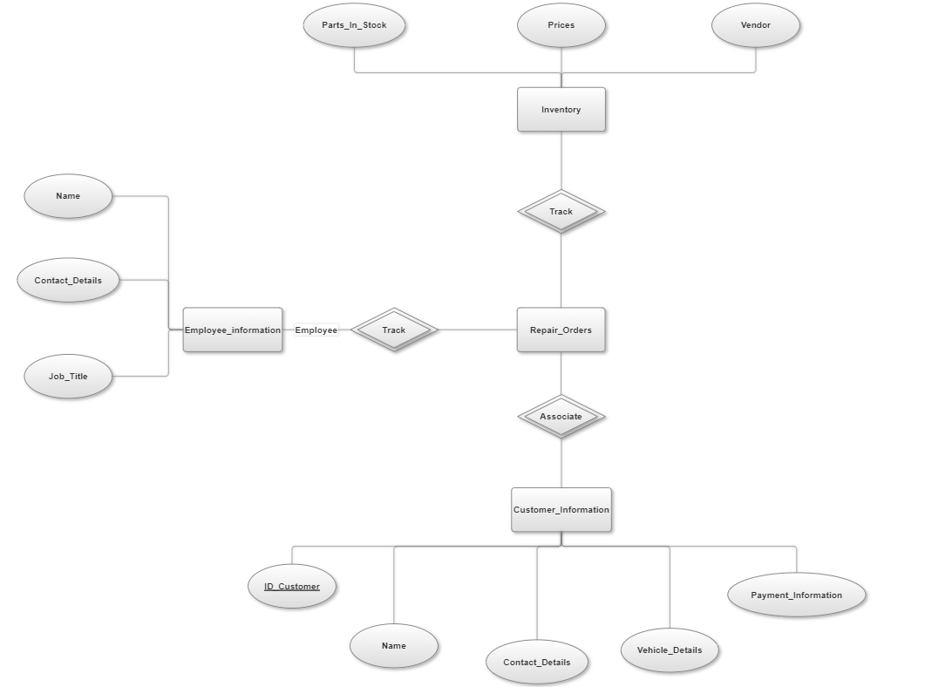

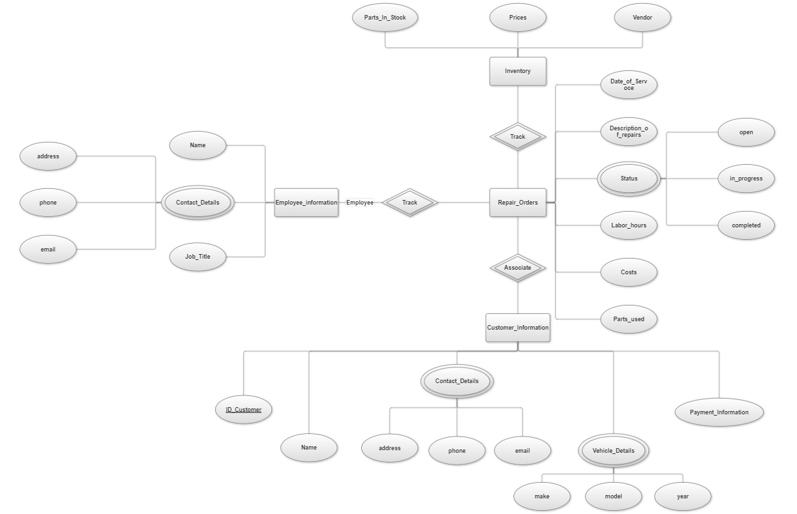

Write about normalization